MasterCard Personal Expense Management System (MPEMS)
Project Plan
Filing Reference : | MPEms_PP
Document Title : | Project Plan
Version : | 1.0
Prepared By : | Lee Zhong De/Rollei
Date Created :
Review By :
 | Lee Zhong De | Date
 | Project Manager
Accepted By :
 | Huang Donghao | Date
 | Project Client
Table of Contents
©1993 ISS.  The information contained in this document is the property of ISS. The contents must not be reproduced, wholly or in part, for purposes other than for which it has been supplied, without the prior permission of ISS, or, if it has been furnished under contract to another party, as expressly authorised under that contract. ISS shall not be liable for any errors or omissions. | ISS
1. Introduction 4
1.1 Back Ground 4
1.2 Purpose 4
1.3 Audience 5
1.4 Organization 5
1.5 References 5
2. Project Approach (not completed) 6
2.1 Project Planning 6
2.2 Requirements Gathering 6
2.3 Analysis 6
2.4 Design 6
2.5 Software implementation 6
3. Work Plan 7
3.1 Activity 1 – Project Planning & Quality Planning 7
3.2 Activity 2 – Requirements Gathering and 8
3.3 Activity 3 – First Quality Audit Meeting 8
3.4 Activity 4 – First Project Presentation 8
3.5 Activity 5 – Analysis Modeling 8
3.6 Activity 6 – High-level Design Modeling 9
3.7 Activity 7 – Prototype 9
3.8 Activity 8 – Second Quality Audit Meeting 9
3.9 Activity 9 – Second Project Presentation 9
3.11 Activity 11 – Implementation 9
3.12 Activity 12 – System Testing 10
3.13 Activity 13 – User Acceptance Testing 10
3.14 Activity 14 – Project Closure 10
3.15 Activity 15 – Third Quality Audit Meeting 10
3.16 Activity 16 – Detailed Design Modeling 11
4. Staff Effort Estimation 12
4.1 Estimated Effort based on COCOMO 12
4.2 Estimated Project Effort based on WBS 13
5. Timescales & Milestones 14
5.1 WBS Activities Timescale 14
5.2 Project Milestones 14
6. Project Deliverables 17
7. Project Structure and Staffing 18
8. Project Resource 20
9. Risk Assessment 21
10. Appendices 23
10.1 Functional Point Count 23
10.2 COCOMO Unadjusted Function Points (Admin and Member Module) 32
10.3 COCOMO Value Adjustment Factor 33
10.4 COCOMO Scaling Factor 34
10.5 COCOMO Cost Drive 35
10.6 Detailed Work Breakdown Structure - by Resources 36
10.7 Detailed Work Breakdown Structure – Activities Start and End Date 40
10.8 Risk Questionaires 44
10.9 Risks Techniques 46

Revision History:

Ver | Date | Author | Remarks
1.0 | 18 Mar 2012 | Lee Zhong De Rollei
1.1
1.2
1.3

Distribution:
Name | Department | Organisation
Huang Donghao | Master Card | Master Card
Dao Xuan Dung | S2 | ISS
Lee Zhong De Rollei | S2 | ISS
Alvin Lee | S2 | ISS
Guo Yu | S2 | ISS
Zhou ZiFeng | S2 | ISS
Jiang Hao Min | S2 | ISS

- Introduction

This project is an academic project supported by Institute of System Science (ISS, NUS). The project client is MasterCard Singapore. The project seeks to develop a system which will provide additional value added services to MasterCard customers. The value added services provided by the new system will enhance customer’s experience with MasterCard and ideally prompt the customers to choose MasterCard as their preferred card.

  - Project Client Back Ground

Throughout the world, MasterCard’s principal business is to process payments between the banks of merchants and the card issuing banks or credit unions of the purchasers who use the "MasterCard" brand debit and credit cards to make purchases.

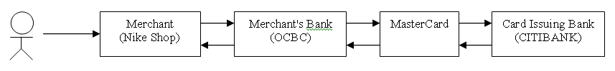

Currently if a customer holds multiple MasterCard from different banks, they will have to manually check their individual card transactions from their card respective banks which can be very inconvenient and time consuming.

The MasterCard Personal Expense Management System seeks to provide the following value added services to all MasterCard holders

- Single point for user to check all their credit/debit cards transactions that are tie to MasterCard Payment Network

- Expense Tracker, allow user to track and analyze their expenses

- Budget Assistance, allow users to organize their budgets and set reminder when their spending exceed their pre-defined budget

- Exclusive MasterCard Deals, allow users to receive exclusive deals only for MasterCard users

- Rewards Program, allow users to earn reward points by spending on their MasterCard. The reward points can be used to exchange vouchers.

  - Purpose

The purpose of this document is to provide the following basis below to the project client and relevant stake holders (e.g. ISS adviser, project team) on how the project will be delivered.

- Goal and objective of the project

- list of tasks that will be undertaken by the project members to fulfill the project requirements

- strategy and approach on how the tasks will be executed by when and by whom

- milestones and check points to meet to ensure project progression

- justification of the project efforts required to fulfill

- risk assessment

  - Audience
- Project Team. This document will provide the following information to the team
  - A plan for the activities that they need to perform
  - The deliverables the team would require to produce
  - Indicate the required effort and timescales for each task that are allocated to them

- Huang Donghao: He is the project’s client and is required to review and accept the specified requirements of the software in this document to ensure that all the user requirements have been addressed.

- ISS Mentors: This project will be mentored by ISS advisers and this document will be subjected for the advisers’ review.

  - Organization

- Institute of System Science, National University of Singapore
  - This project will be oversee by ISS, NUS

- MasterCard Singapore.
  - MasterCard is the client for the project that will be undertaken by ISS students

  - References
To fully understand the background to this project, the reader should also be familiar with:
1. MPEMS Requirements Specifications, reference [MPEMS/PM-1.2.1], version 1.1, dated 10 Mar 2012
2. MPEMS Quality Plan, reference [MPEMS/PM-1.3.1], version 1.0, dated 10 Mar 2012
2. Project Approach (not completed)

The project will be initiated with a formal project plan and quality plan. The quality plan approach will be covered in the quality plan document. The approach that will be taken during project execution will be as follow:

2.1 Project Planning

A work breakdown structure (WBS) will be created to list down the activities that will be undertaken by the team member to fulfill the project requirements. Each activities defined in the WBS will be translated into man-day effort by project team’s judgment based on the team’s past experience and resource constraints

To verify the estimation made by the team’s judgment, a separate effort estimation will be conducted using COCOMO, Functional Point Count (FPC). The total effort derived from team’s judgment will be compared against COCOMO derived estimates. If required, necessary adjustments will be made to the WBS activities.

Based on the estimated man-days, a project schedule will be produced in Microsoft project. The project schedule will indicate

- the start and end date for each activity

- the effort required for each activity

- the resource(s) allocated to each activity

- the interdependencies between activities

- project activity milestones

Risk assessment will also be undertaken as part of the project plan. All potential risks which will impact the success of the project will be identified and prioritized (for monitoring) through risk questionnaires. Techniques/measurements to avoid/mitigate each risk identified will also be defined in the project plan.

2.2 Requirements Gathering
The requirements will be captured through user interviews. A total of 2 interviews session, each lasting 2 hours will be conducted. After each interviews, the requirements will be captured in a formal requirements specifications. The requirement specifications document will then be sent to the interviewees for verifications and clarifications (if required). After all the requirements have been captured in the requirement specification, the project client will do a formal sign off to acknowledge and accept the requirements specifications.

2.3 Analysis

The requirements captured in the requirements specifications will be analyzed and translated into Use Case Model Survey (USMS). Major Use Cases defined in USMS will be further analyzed and translated to their respective Use Case Realization Report (UCRR). Around the same time, the solution architect will kick start the system high-level architecture design. Upon the completion of USMS, UCRR and high-level design, a prototype will be built based on the major requirements captured in USMS, UCRR and high-level design.

Together with prototype development, a User Interface Specifications (UIS) will also be created. The prototype created will be studied and tested by the team member together with the project client. All findings discovered during prototype testing will be documented into a Prototype Study Report. If required, adjustments will also be made to the USMS, UCRR and UIS to reflect and critical change of design decision.

The documentations created during the analysis phase will be compiled as a Function Specifications which compasses the analyzed requirements represented in UML and the User Interface design. This document will have to be supported and signed off by the project client

2.4 Design
The analyzed requirements captured in functional specifications will be translated to a detailed design specification. The solution architect will define the transition strategy from analysis to design based on the chosen libraries, platform and tool that will be used to develop the system.

2.5 Software implementation
3. Work Plan

The following work/activity has been planned to be executed during different phases of the project.
The following activities will conducted to ensure the project meet the MTech Project Requirements and the System Requirements provided by the project client

These activities will be executed in different phases of the project

SN | Phase | Activities
1 | Project Planning | Activity 1: Project Planning & Quality Planning  Activity 2: Requirement Gathering & Analysis  Activity 3: First Quality Audit Meeting  Activity 4: First Project Presentation
2 | Analysis and Design | Activity 5: Analysis Modeling  Activity 6: High-Level Design Modeling  Activity 7: Prototyping  Activity 8: Second Quality Audit Meeting  Activity 9: Second Project Presentation
3 | Implementation | Activity 10: Detailed Design Modeling  Activity 11: Implementation  Activity 12: System Testing  Activity 13: User Acceptance Testing  Activity 14: Project Closure  Activity 15: Third Quality Audit Meeting  Activity 16: Third Project Presentation

The description of each activities in the work plan is as follow:

3.1 Activity 1 – Project Planning & Quality Planning

The project will kick start after the kick-off meeting with the project client. A central file repository will also be created to store all project documents. Project PM and QA will proceed with the project and quality planning based on the high level requirements gathered during the kick-off meeting. At the end of this activity, the project and quality plan must be produced.

3.2 Activity 2 – Requirements Gathering and

This activity will kick start together with project and quality planning. 2 requirements gathering meeting will be conducted to get the detailed requirements from the users (3 employees from MasterCard). At the end of this activity, a user requirement specifications must be completed and signed off by the project client.

3.3 Activity 3 – First Quality Audit Meeting
This activity is the first quality audit check point which has been put in place as part of the project activity to ensure the project has adequate quality planning and the project team is adhering to the quality plan when executing the project task. The output created from activity 1 and 2 (e.g. project, quality planning and requirements specifications will also be submitted during this time for ISS mentors to review)

3.4 Activity 4 – First Project Presentation
This activity is the first project presentation for the project team to present to ISS mentors on the project plan, quality plan, project status and challenges faced by the team. All comments, advices and recommendations made by the adviser will be considered carefully by the team. At the end of this activity, the revised project plan and requirement specifications will be shared with the project client. This will give the project client an idea on what they can expect from the project and the system produced from this project.

3.5 Activity 5 – Analysis Modeling

After the project plan, quality plan and requirement specifications have been reviewed and supported by ISS mentors and project client. The project team will proceed with the analysis modeling phase.

The initial phase in this activity is to translate user requirements into UML notation, the translated requirements in UML notation will be documented as User Case Model Survey (USMS) and Use Case Realization Report (UCRR).

The second part of this activity is to create a User Interface Design Specification (UIS). This will be done concurrently with activity 5 by the business analyst and solution architect. At the end of this activity, the finalized functional specifications which will consist of (USMS, UCRR and UIS) will be produced.

3.6 Activity 6 – High-level Design Modeling

Concurrently with activity 4, this activity will kick start with User Interface Design as soon as the USMS and UCRR has been reviewed and finalized. This activity seeks to propose a strategy to translate requirements specifications to design specifications. At the end of this activity a high level design specification will be produced.

3.7 Activity 7 – Prototype

After the high-level design specifications have been produced, a prototype will be built to verify the high level design. The prototype will be carefully studied and reviewed by the business analysis, quality manager and project manager. All findings, suggestions and comments from the prototype study will be documented. The prototype study document will be reviewed and any necessary adjustments to the design will be updated to the high-level design specifications.

3.8 Activity 8 – Second Quality Audit Meeting
After the analysis and high level design modeling is completed. The team will be subjected to second quality audit check. This activity is to ensure that the project team has continuously executed the project task based on quality plan. The output created from activity 4, 6 and 7 (e.g. Functional Specifications, High-Level design specification and prototype study) will also be submitted during this time for ISS mentors to review)

3.9 Activity 9 – Second Project Presentation

The second project presentation will be conducted to further update ISS mentors the status of the project. If the project schedule slide, the project team will have to provide explanation for the slippage. At the end of this activity, the revised functional and high-level design specification will be shared with the project client.

3.10 Activity 10 – Detailed Design Modeling

After the functional and high-level design specifications have been reviewed and supported by ISS mentors and project client. The project team will proceed with the detailed design modeling phase.

This activity will translate analysis models defined in the analysis phase to design models based on the architecture proposed in the high-level design specifications. Only critical use case will be covered in the design modeling. At the end of this activity, a reviewed and finalized detailed design specification will be produced.

3.11 Activity 11 – Implementation

Once the detailed design modeling has been completed. Majority of the team member will proceed to program the application based on the detailed design specification. Each team member will be tasked to program a module and conduct it ensuing unit testing. At the end of the coding and unit testing phase, the team will conduct peer review on one another’s code. The corrective action will have to be done during the peer review.

3.12 Activity 12 – System Testing

The initial phase of this activity to create test script and test plan will kick start together with Activity 11 – Implementation. The system test will commence immediately after the completion of implementation. The system test will be conducted by internally by the team’s project manager and test manager. All observations and bugs encountered during the testing will be documented for further review. Any corrective actions will be undertaken after the system test review.

3.13 Activity 13 – User Acceptance Testing

Once the system has been tested successfully internally within the team, the solution architect will proceed to setup a separate UAT environment. The project manager, quality manager and business analysis schedule a pre-uat briefing with the tester. During the briefing, the business analyst will walk through the system with the testers and also brief the tester on bugs report procedures. After which the testers will be given 1 week to test the system. No formal test session will be scheduled, the testers will test the system as and when they’re available. After the first UAT cycle is completed, the bugs will be collated for review. The review will determine if there will be any corrective actions to be taken. A regression testing to verify the corrective actions will be conducted. At the end of UAT, all test results and action taken to correct the problem will be documented in a formal Test Result Document.

3.14 Activity 14 – Project Closure

Once the UAT has completed, the project team will proceed to create the user guide for the system and also final project report. Upon the completion of the user guide, the project manager will schedule a project closure meeting with the project client. During the closure meeting, the client will formally sign off the project and all source codes and documents related to the project will be handed over to the client. At the end of this activity, the project will be sign-off, the final project report will also be completed

3.15 Activity 15 – Third Quality Audit Meeting

The final Quality Audit Meeting will be conducted to conclude the project quality adherence. The remaining deliverables will also be submitted during this time

3.16 Activity 16 – Detailed Design Modeling

In the last activity, the project team will demonstrate the system to ISS mentors and present the lessons learn during the whole project.
4. Staff Effort Estimation

4.1 Estimated Effort based on COCOMO

The estimated effort for the scope of this project based on COCOMO using Functional Point Count is 12.1 Person-Months which is equivalent to 368 man days.

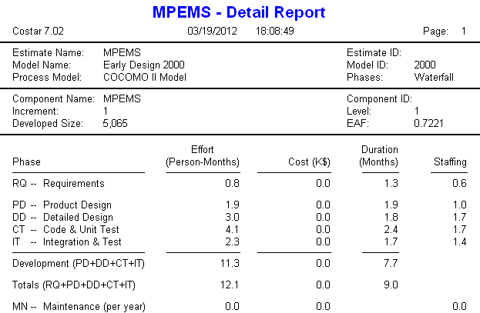

* refer to appendix 10.1 for Functional Point Count
* refer to appendix 10.2 for COCOMO Unadjusted Function Points
* refer to appendix 10.3 for Value Adjustment Factor
* refer to appendix 10.4 for Scaling factor
* refer to appendix 10.5 for Cost Driver

4.2 Estimated Project Effort based on WBS

The estimated effort for the scope of this project based on WBS and project experience is 371.5 Man days

Activity ID | Task Name | Est. Man Day
1 | Project Planning & Quality Planning | 24.5
2 | Requirement Analysis | 14
3 | First Quality Audit Meeting | 5
4 | First Project Presentation | 4.5
5 | Analysis Modeling | 66
6 | High Level Design Modeling | 19
7 | Prototype | 35
8 | Second Quality Audit Meeting | 5
9 | Second Project Presentation | 4.5
10 | Detailed Design Modeling | 27.5
11 | Implementation | 56
12 | System Testing | 37
13 | User Acceptance Testing | 26.5
14 | Project Closure | 27.5
15 | Third Quality Audit Meeting | 5
16 | Third Project Presentation | 14.5
 | Total | 371.5

* refer to appendix 10.6 for detailed Work Breakdown Structure – By Resource
* refer to appendix 10.6 for detailed Work Breakdown Structure – Activity Start and End date

5. Timescales & Milestones

5.1 WBS Activities Timescale
Phase | Activity ID | Task Name | Start Date | Finish Date
Project Planning | 1 | Project Planning & Quality Planning | Sat 1/28/12 | Sun 4/1/12
Project Planning | 2 | Requirement Analysis | Sat 2/25/12 | Sun 4/1/12
Project Planning | 3 | First Quality Audit Meeting | Sun 4/1/12 | Tue 4/3/12
Project Planning | 4 | First Project Presentation | Sat 4/7/12 | Tue 4/10/12
Analysis and Design | 5 | Analysis Modeling | Wed 4/11/12 | Sat 8/11/12
Analysis and Design | 6 | High Level Design Modeling | Sat 5/26/12 | Sun 7/8/12
Analysis and Design | 7 | Prototype | Mon 7/9/12 | Sat 8/11/12
Analysis and Design | 8 | Second Quality Audit Meeting | Sat 8/11/12 | Tue 8/14/12
Analysis and Design | 9 | Second Project Presentation | Sat 8/18/12 | Tue 8/21/12
Implementation | 10 | Detailed Design Modeling | Wed 8/22/12 | Sun 9/9/12
Implementation | 11 | Implementation | Mon 9/10/12 | Sat 9/29/12
Implementation | 12 | System Testing | Mon 9/10/12 | Sat 10/13/12
Implementation | 13 | User Acceptance Testing | Sun 10/14/12 | Sun 12/2/12
Implementation | 14 | Project Closure | Mon 12/3/12 | Sun 12/30/12
Implementation | 15 | Third Quality Audit Meeting | Sat 1/5/13 | Tue 1/8/13
Implementation | 16 | Third Project Presentation | Tue 1/1/13 | Tue 1/15/13

* refer to appendix 10.6 for detailed Work Breakdown Structure – Activity Start and End date

5.2 Project Milestones

SN | Activity | Approx. Date
1. | Project Planning & Quality Planning
 | Completed Project Planning | 01 Apr 2012
 | Completed Quality Planning | 01 Apr 2012
2 | Requirement Analysis
 | Completed Requirements Gathering | 01 Apr 2012
3 | First Quality Audit
 | Completed First Quality Audit | 03 Apr 2012
 | Submitted Phase 1 Deliverables | 03 Apr 2012
4 | First Project Presentation
 | Completed First Project Presentation | 10 Apr 2012
5 | Analysis Modeling
 | Completed Use Case Model Survey (USMS) | 28 Apr 2012
 | Completed Use Case Realization Report (UCRR) | 26 May 2012
 | Completed User Interface Design Specification (UIDS) | 20 Jul 2012
 | Completed Functional Specification (FS) | 11 Aug 2012
6 | High Level Design Modeling
 | Completed High Level Design Modeling | 11 Aug 2012
7 | Prototype
 | Completed Prototype | 22 July 2012
 | Completed Prototype Study Review | 11 Aug 2012
8 | Second Quality Audit
 | Completed Second Quality Audit | 14 Aug 2012
 | Submitted Phase 2 Deliverables | 14 Aug 2012
9 | First Project Presentation
 | Completed First Project Presentation | 21 Aug 2012
10 | Detailed Design Modeling
 | Completed Detailed Design Specification | 09 Sep 2012
11 | Implementation
 | Completed Coding, Unit Testing and Peer Review | 23 Sep 2012
12 | System Testing
 | Completed Test Plan/Script | 23 Sep 2012
 | Completed System Testing | 13 Oct 2012
13 | User Acceptance Testing
 | Completed UAT | 16 Nov 2012
 | Completed Test Documentation | 02 Dec 2012
14 | Project Closure
 | Completed Final Project Report | 30 Dec 2012
 | Completed User Guide | 21 Dec 2012
 | Handed over the system to project client | 28 Dec 2012
15 | Third Quality Audit Meeting
 | Completed Third Quality Audit | 08 Jan 2013
 | Submitted Phase 3 Deliverables | 08 Jan 2013
16 | Third Quality Audit Meeting
 | Completed First Project Presentation | 15 Jan 2013
 | Project Completion | 15 Jan 2013

6. Project Deliverables

As a result of undertaking the work described in the work plan, the following deliverables will be produced at different phase of the project.

SN | Phase | Deliverables
1 | Project Planning | - Project Plan  - Quality Plan  - User Requirement Specification
2 | Analysis and Design | - Functional Specification  - Prototype Study Report  - Detailed Design Specification
3 | Implementation | - Source and Executable  - Test Documentation  - User Guide  - End of Project Report

7. Project Structure and Staffing

Project Role |  | Personnel | Responsibility
ISS | ISS Mentors | ISS | Provide project advisory to the team
PM | Project Manager | Lee Zhong De | - Develop Project Plan  - Manage project schedule, risk and change request  - Liaise with Project Stake Holders  - Ensure timely completion of deliverables  - Facilitate User Sign-Off
QM | Quality Manager | Lee Mingjian Alvin | - Develop Quality Plan  - Ensure the quality plans are executed accordingly  - Validate product created meets quality requirements  - Provide advices on matters relating to product quality
BA | Business Analyst | Dao Xuan Dung Thomas | - Develop User Requirement Specifications  - Conduct interviews to gather requirements  - Document meeting minutes  - Assist in Prototype Review, SIT, UAT
SA | Solution Architect | Guo Yu | - Develop Design Specifications  - System Architecture  - Database Design  - Responsible for all installation, deployment and development/test environment setup with the assistant from Implementation Managers
IM | Implementation Manager | Jiang Hao Min, | - Assist Solution Architect to Develop Design Specifications  - Prototype Creation  - Integration of Code Modules  - Source Code Management
TM | Test Manager | Zhou Zi Feng | - Prepare and support UAT testing  - Testing documentation
UM | User Manager | Huang Dong Hao  (Client Representative) | - Provide user requirements  - Review and accept project deliverables
TT | Tester | 3 Master Card Employee | - Perform Testing accordance to test plan  - Report Issues

8. Project Resource

All development work will be undertaken in the project team’s personal notebook. No additional office space will be setup. However, a project server provided by ISS will be used as a central repository to store project documents and source code.

Computer Hardware and Software

- Hardware
  - 1 x Server (Provided by ISS)
  - Project Team Member Personal Notebook

- Software
  - Windows Server 2008r2 (pre-installed)
  - Weblogic
  - Java 1.6
  - Oracle Database
9. Risk Assessment

The following potential risks have been identified.
SN | Risk Item | Impact |  |  |  |  |  | Likelihood |  |  |  |  |  | Total
SN | Risk Item | 1 | 2 | 3 | 4 | 5 | Total | 1 | 2 | 3 | 4 | 5 | Total | Total
 | Team member departure and unavailability |  | x | x |  |  | 2 |  |  | x |  |  | 1 | 3
 | Project client commitment to the project and availability | x | x | x | x |  | 4 |  |  | x |  | x | 2 | 6
 | Insufficient hardware resource |  | x | x |  |  | 2 |  |  | x |  |  | 1 | 3
 | System portability risk |  |  |  | x |  | 1 |  | x |  |  |  | 1 | 2
 | Dependency on third-party library and lack of experience in third-party library |  |  |  | x |  | 1 |  | x |  |  |  | 1 | 2
 | Lack of experience in UI design for Mobile Website |  |  |  | x |  | 1 |  | x |  |  |  | 1 | 2
 | Uncertainty/insufficient requirements |  |  |  | x | ‘ | 1 |  |  | x |  |  | 1 | 2

* refer to appendix 10.8 for Risk Questionnaires
* refer to appendix 10.9 for Risk Techniques
Impact Legend | Likelihood Legend
1: Reduced Functionality | 1: Novelty
2: Increased Cost | 2: Product History
3: Schedule Slippage | 3: Project Team History
4: Quality Cost | 4: Recognized Authority
5: Performance | 5: Expectation

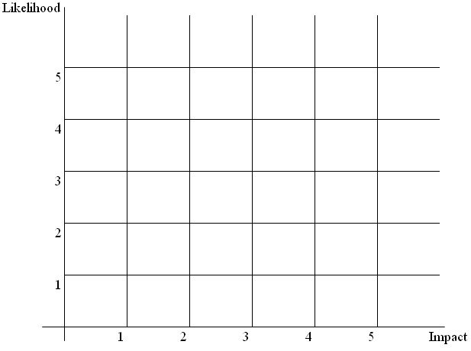
Risk (4, 5, 6, 7)
Risk (1, 3)
Risk (2)
10. Appendices

10.1 Functional Point Count

Admin Module Data Function

Internal Logical File/External Interface File |  |  | Elements of complexity
Type | Reference | Description | DET | RET | Complexity
ILF | URS 3.3 | Administrator Login | 3 | 1 | L
 |  | Login ID
 |  | Login Password
 |  | Administrator Name
ILF | URS 3.7.1 | Deals Details | 8 | 1 | L
 |  | Deal ID
 |  | Deal Title
 |  | Deal Description
 |  | Deal Start date
 |  | Deal End Date
 |  | Deal Image File Link
 |  | Deal Category
 |  | Deal Meta Tags
ILF | URS 3.10.1 | Voucher Details | 7 | 1 | L
 |  | Voucher ID
 |  | Voucher Title
 |  | Voucher Description
 |  | Redemption Points
 |  | Voucher Image Link File
 |  | Voucher Category Type
 |  | Quantity
ILF | URS 3.8 | Redemption Details | 7 | 1 | L
 |  | Redemption ID
 |  | Login ID
 |  | Redemption Date
 |  | Voucher ID
 |  | Quantity
 |  | Address Gift Voucher to Sent
 |  | Redemption Status
ILF | URS 3.11 | Merchant Details | 5 | 1 | L
 |  | Merchant ID
 |  | Merchant Name
 |  | Merchant Address
 |  | Merchant Contact
 |  | Merchant Category
ILF | URS 3.8 | Transaction Category | 2 | 1 | L
 |  | Transaction Category ID
 |  | Transaction Name

Admin Module Transaction Function

External Input/External Output/External Inquiry |  |  | Elements of complexity
Type | Reference | Description | DET | FTR | Complexity
EI | URS 3.7.1 | Create MasterCard Deals | 8 | 1 | L
 |  | Deal ID
 |  | Deal Title
 |  | Deal Description
 |  | Deal Start date
 |  | Deal End Date
 |  | Deal Image File Link
 |  | Deal Category
 |  | Deal Meta Tags
EI | URS 3.7.1 | Update MasterCard Deals Details | 8 | 1 | L
EI | URS 3.7.1 | Delete MasterCard Deal | 1 | 1 | L
 |  | Deal ID
EI | URS 3.10 | Create Voucher | 7 | 1 | L
 |  | Voucher ID
 |  | Voucher Title
 |  | Voucher Description
 |  | Redemption Points
 |  | Voucher Image Link File
 |  | Voucher Category Type
 |  | Quantity
EI | URS 3.10 | Update Voucher Details | 7 | 1 | L
EI | URS 3.10 | Delete Voucher | 1 | 1 | L
 |  | Voucher ID
EI | URS 3.9 | Update Member Status | 2 | 1 | L
 |  | Login ID
 |  | Status (active, inactive, suspended)
EI | URS 3.10 | Update Redemption Status | 2 | 1 | L
 |  | Redemption ID
 |  | Status
EQ | URS 3.3 | Secured Login
 |  | Input | 2 | 1 | L
 |  | Login ID
 |  | Passwword
 |  | Output
 |  | -
EQ | URS 3.7.1 | Search and View MasterCard Deals
 |  | Input | 2 | 1 | L
 |  | Key Word
 |  | Catgory
 |  | Output | 7 | 1 | L
 |  | Deal ID
 |  | Deal Title
 |  | Deal Description
 |  | Deal Start date
 |  | Deal End Date
 |  | Deal Image File Link
 |  | Deal Category
EQ | URS 3.10 | Search and View Vouchers
 |  | Input | 2 | 1 | L
 |  | Search Criteria
 |  | Search Value
 |  | Output | 6 | 1 | L
 |  | Voucher ID
 |  | Voucher Title
 |  | Voucher Description
 |  | Redemption Points
 |  | Voucher Image Link File
 |  | Voucher Category Type
 |  | Quantity
EQ | URS 3.8 | Search and View Redemptions
 |  | Input | 2 | 1 | L
 |  | Search Criteria
 |  | Search Value
 |  | Output | 7 | 2 | A
 |  | Redemption ID
 |  | Redemption Date
 |  | Customer Name
 |  | Voucher ID
 |  | Quantity
 |  | Address Gift Voucher to Sent
 |  | Quantity
EQ | URS 3.9 | Search and View Members
 |  | Input | 2 | 1 | L
 |  | Search Criteria
 |  | Search Value
 |  | Output | 9 | 2 | A
 |  | Login ID
 |  | Name
 |  | Mobile Number
 |  | Email Address
 |  | Home Address
 |  | Reward Points
 |  | Status (active, inactive, suspended)
 |  | Login Attempts
 |  | Credit Card(s)

Member Module Data Function

Internal Logical File/External Interface File |  |  | Elements of complexity
Type | Reference |  | DET | RET | Complexity
ILF | URS 3.1.1.1 | Member Details | 6 | 1 | L
 |  | Login ID
 |  | Login Password
 |  | Name
 |  | Mobile Number
 |  | Email Address
 |  | Home Address
ILF | URS 3.1.1.2 | Credit Card Details | 9 | 1 | L
 |  | Name on the Credit Card
 |  | Credit Card Number
 |  | Credit Card Expiry Date
 |  | Credit Card CVV2
 |  | Credit Card Issuer Bank
 |  | Credit Card Country
 |  | Daily Budget
 |  | Weekly Budget
 |  | Month Budget
ILF | URS 3.5.1 | Transaction Details | 9 | 1 | L
 |  | Merchant ID
 |  | TxnType
 |  | TxnDateTime
 |  | Acct - CreditCard Number
 |  | ExpDate
 |  | Amount
 |  | Currency
 |  | Cvv2
 |  | Category
ILF | URS 3.8 | Redemption Details | 6 | 1 | L
 |  | Redemption ID
 |  | Redemption Date
 |  | Voucher ID
 |  | Quantity
 |  | Address Gift Voucher to Sent
 |  | Redemption Status

Member Module Transaction Function

External Input/External Output/External Inquiry |  |  | Elements of complexity
Type | Reference | Description | DET | FTR | Complexity
EI | URS 3.1 | Account Registration | 15 | 2 | A
 |  | Login ID
 |  | Login Password
 |  | Name
 |  | Mobile Number
 |  | Email Address
 |  | Home Address
 |  | Name on the Credit Card
 |  | Credit Card Number
 |  | Credit Card Expiry Date
 |  | Credit Card Cvv2
 |  | Credit Card Issuer Bank
 |  | Credit Card Country
 |  | Daily Budget
 |  | Weekly Budget
 |  | Month Budget
EI | URS 3.4 | Update Account Details | 4 | 1 | L
 |  | Name
 |  | Mobile Number
 |  | Email Address
 |  | Home Address
EI | URS 3.2 | Reset Password | 1 | 1 | L
 |  | Login ID
EI | URS 3.4 | Change Password | 2 | 1 | L
 |  | Old Password
 |  | New Password
EI | URS 3.4 | Add new MasterCard to Account | 9 | 1 | L
 |  | Name on the Credit Card
 |  | Credit Card Number
 |  | Credit Card Expiry Date
 |  | Credit Card Cvv2
 |  | Credit Card Issuer Bank
 |  | Credit Card Country
 |  | Daily Budget
 |  | Weekly Budget
 |  | Month Budget
EI | URS 3.4 | Subscribe/Unsubscribe to Deal Category | 2 | 2 | L
 |  | Login ID
 |  | Deal Category
EI | URS 3.5 | Assign Transaction to specific Category | 2 | 1 | L
 |  | Transaction ID
 |  | Category ID
EI | URS 3.6 | Assign Budget to individual Card | 4 | 1 | L
 |  | Credit Card Number
 |  | Daily Budget
 |  | Weekly Budget
 |  | Monthly Budget
EI | URS 3.8 | Redeem Voucher | 3 | 2 | L
 |  | Voucher ID
 |  | Quantity
 |  | Address Gift Voucher to Sent
EI | URS 3.6 | Assign Overall Budget | 2 | 1 | L
 |  | Period (weekly/monthly)
 |  | Budget
EO | URS 3.1 | Registration Email Confirmation | 6 | 2 | A
 |  | Name
 |  | Mobile Number
 |  | Email Address
 |  | Home Address
 |  | CreditCard Number (Masked)
 |  | Confirmation Message
 |  | Confirmation Link
EO | URS 3.1 | Registration SMS Notification | 3 | 2 | L
 |  | Name
 |  | CreditCard Number (Masked)
 |  | Notification Message
EO | URS 3.6 | Budget Exceed SMS Notification | 6 | 2 | A
 |  | Name
 |  | CreditCard Number (Masked)
 |  | Total Spending
 |  | Buget
 |  | Period
 |  | Notification Message
EO | URS 3.4 | Password Change SMS Notification | 2 | 1 | L
 |  | Name
 |  | Notification Message
EO | URS 3.3 | Fail Login SMS Notificaion | 3 | 1 | L
 |  | Name
 |  | Login ID
 |  | Notification Message
EQ | URS 3.3 | Secured Login
 |  | Input | 2 | 1 | L
 |  | Login ID
 |  | Password
 |  | Output
 |  | -
EQ | URS 3.5 | View My MasterCards
 |  | Input | 2 | 1 | L
 |  | Login ID
 |  | Output | 6 | 1 | L
 |  | Name on the Credit Card
 |  | Credit Card Number
 |  | Credit Card Expiry Date
 |  | Credit Card CVV2
 |  | Credit Card Issuer Bank
 |  | Credit Card Country
EQ | URS 3.5 | Search and View Transaction
 |  | Input | 3 | 1 | L
 |  | Credit Card Number
 |  | Search Criteria
 |  | Search Value
 |  | Output | 7 | 3 | A
 |  | Merchant Name
 |  | TxnType
 |  | TxnDateTime
 |  | Acct - CreditCard Number
 |  | Amount
 |  | Currency
 |  | Category
EQ | URS 3.5 | View Reports Graphs
 |  | Input | 3 | 1 | L
 |  | Type Of Report
 |  | Start Date
 |  | End Date
 |  | Output | 2 | 1 | L
 |  | X Coordinates
 |  | Y Coordinates
EQ | URS 3.7 | Search and View MasterCard Deals
 |  | Input | 2 | 1 | L
 |  | Key Word
 |  | Catgory
 |  | Output | 7 | 1 | L
 |  | Deal ID
 |  | Deal Title
 |  | Deal Description
 |  | Deal Start date
 |  | Deal End Date
 |  | Deal Image File Link
 |  | Deal Category
EQ | URS 3.10 | Search and View Vouchers
 |  | Input | 2 | 1 | L
 |  | Key Word
 |  | Catgory
 |  | Output | 6 | 1 | L
 |  | Voucher ID
 |  | Voucher Title
 |  | Voucher Description
 |  | Redemption Points
 |  | Voucher Image Link File
 |  | Voucher Category
EQ | URS 3.8 | Search and View Redemptions
 |  | Input | 2 | 1 | L
 |  | Search Criteria
 |  | Search Value
 |  | Output | 5 | 2 | A
 |  | Redemption Date
 |  | Voucher ID
 |  | Voucher Title
 |  | Address Gift Voucher to Sent
 |  | Quantity Redeemed

10.2 COCOMO Unadjusted Function Points (Admin and Member Module)

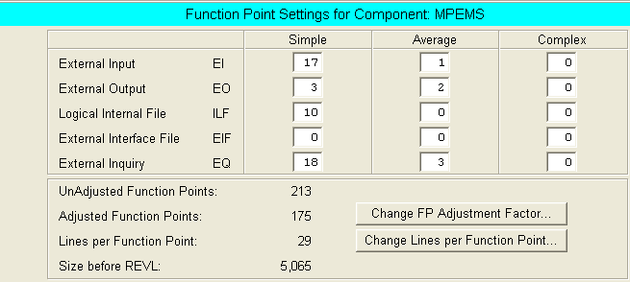

10.3 COCOMO Value Adjustment Factor

CHARACTERISTIC | DI | Remarks
Data Communications | 3 | The new system will use client server model where multiple clients will concurrently query the server to download data. However, the server will not initial a connection to the client. The expected number of subscribers may cross 100,000.
Distributed Functions | 2 | The system will use n-tier architecture design where some of the data processing capabilities will spread across different computers. E.g. Application may first process the data and send the processed data to its database. At the database, the data may further be processed before the data is been stored in the database.
Performance | 2 | There is a quality requirements where the response time for each page should not exceed x seconds. The system must be properly designed (load on demand via AJAX) to ensure that the web page will not be too heavy to load.
Heavily Used Configuration | 0 | No explicit or implicit operational restrictions are included.
Transaction Rate | 1 | The users will use the system as and when required. There is no peak transaction period anticipated
On-Line Data Entry | 2 | Around 20% of the transactions are interactive data entry. The remaining transactions are mainly data retrieving which do not involve data entry. Data entry is largely for system administration. Which has relatively low usage
End User efficiency | 2 | System will be displayed on different device. A desktop screen typical 17” and a handheld screen typical 3.5”. The system must be carefully designed to achieve user friendliness
On-line Update | 2 | 30% of the system data is modifiable by users. However, as of the current requirements there is no need for special measurements that need to be put in place to protect the data.
Complex Processing | 0 | The new system is created to provide value added services to mastercard holder. It is not a mission critical application which require complex processing to ensure all requests can be processed
Re-usability | 2 | The code should be moderately reusable
Installation Ease | 0 | No special considerations were stated by the user, and no special setup is required for installation
Operational Ease | 0 | No special operational considerations other than the normal back-up procedures.
Multiple Sites | 0 | User requirements do not require considering the needs of more than 1 installation site. Future expansion due to high usage can be done through load balancing server which do not require the system to be redesigned/
Facilitate Change | 1 | The search function provided e.g. search transactions will be designed to allow mid-complexity search query. E.g. with and/or clause.
Total Degree of Influence | 17

10.4 COCOMO Scaling Factor

Scaling Factors | Description | Remarks
PRECEDENTEDNESS | The system will be developed in java and will be run on web browser. Majority of the team members have considerably good experience in developing web application using Java. | Generally Familiar
DEVELOPMENT FLEXIBILITY | The development schedule and deliverables are fixed. The project must generally conform to ISS delivery standards. Project client is relatively flexible and accommodative to the timeline and documentation format | General Conformity
ARCHITECTURE/RISK RESOLUTION | Completed high-level architecture design. Risk has been assessed and measurements will be put in place to mitigate potential risk | Often
TEAM COHESION | Majority of the team member gained positive experience working together in the past. | Highly Cooperative
PROCESS MATURITY | Based on RUP | SEI CMM Level2

10.5 COCOMO Cost Drive

Factors |  | Rating | Remarks
Personnel | PERS | High | Majority of the team members are familiar with the platform, language, tools and IDE that will be used in this project
Personnel | PREX | High | Majority of the team members have relevant experience in web application development project
Platform | PDIF | Nominal | The system will be developed on windows os as the platform. No special system design is needed due to platform constraint.
Product | RCPX | Nominal | The criticality of the system is considerably. System failure will not result in significant financial damage. Only moderate reliability is required.
Product | RUSE | Nominal | Some of the system functions may potentially be reused for marketing purposes. E.g. deal and voucher management. The system may needs to be designed for some reusability. E.g. MasterCard deals created in the system may be exposed as a web service in future to marketing purposes
Project | FCIL | Nominal | No special facilities will be required. All facilities, required has been made available by the stake holder.
Project | SCED | High | The project schedule is fix.

10.6 Detailed Work Breakdown Structure - by Resources

Task ID | Task Name | Resources |  |  |  |  |  | Total
Task ID | Task Name | ZD | ALVIN | TOM | GY | HM | ZF | Total
Task ID | Task Name | PM | QM | BA | SA | IM | TM | Total
1 | Project Planning & Quality Planning |  |  |  |  |  |  | 24.5
1.1 | Kick Off Meeting | 0.5 | 0.5 | 0.5 |  |  |  | 1.5
1.2 | Create File Repository |  | 1 |  |  |  |  | 1
1.3 | Create Project Plan | 5 |  |  | 2 |  |  | 7
1.4 | Review, Update and Finalize Project Plan | 2 |  |  | 2 |  |  | 4
1.5 | Create Quality Plan |  | 5 |  |  |  | 2 | 7
1.6 | Review, Update and Finalize Quality Plan |  | 2 |  |  |  | 2 | 4
2 | Requirement Analysis |  |  |  |  |  |  | 14
2.1 | Initial Requirements Gathering - Interviews | 1 | 1 | 1 |  |  |  | 3
2.2 | Create User Requirement Specifications |  |  | 5 |  | 2 |  | 7
2.1 | Review, Update and Finalize User Requirement Specifications |  |  | 2 |  | 2 |  | 4
3 | First Quality Audit Meeting |  |  |  |  |  |  | 5
3.1 | Print and Upload Deliverables | 0.5 |  |  |  | 0.5 |  | 1
3.2 | Review, Update Quality Audit Check List |  | 0.5 |  |  |  | 0.5 | 1
3.3 | First Quality Audit Meeting | 0.5 | 0.5 | 0.5 | 0.5 | 0.5 | 0.5 | 3
4 | First Project Presentation |  |  |  |  |  |  | 4.5
4.1 | Review and Update Project Progress/Status | 0.5 |  |  |  |  |  | 0.5
4.2 | Presentation Preparation | 1 |  |  |  |  |  | 1
4.3 | First Project Presentation | 0.5 | 0.5 | 0.5 | 0.5 | 0.5 | 0.5 | 3
5 | Analysis Modeling |  |  |  |  |  |  | 66
5.1 | Create Use Case Diagram |  |  | 0.5 | 0.5 | 0.5 | 0.5 | 2
5.2 | Create Use Case Model Survey (USMS) |  |  | 2 | 2 | 2 | 2 | 8
5.3 | Review, Update and Finalize USMS | 2 | 2 |  |  |  |  | 4
5.4 | Identify Analysis Objects |  |  | 0.5 | 0.5 | 0.5 | 0.5 | 2
5.5 | Create Class and Diagram – Analysis |  |  |  | 2 | 2 | 2 | 6
5.6 | Create Collaboration Diagram - Analysis |  |  |  | 2 | 2 | 2 | 6
5.7 | Create Use Case Realization Report (UCRR) |  |  | 3 | 3 | 1 | 1 | 8
5.8 | Review, Update and Finalize UCRR | 2 | 2 |  |  |  |  | 4
5.9 | Create User Interface Specification (UIS) |  |  | 4 |  |  | 4 | 8
5.1 | Review, Update and Finalize UIS | 2 | 2 |  |  |  |  | 4
5.11 | Create Functional Specification (consists of USMS, UCRR, UIS) |  |  | 2 | 2 | 2 | 2 | 8
5.12 | Review, Update and Finalize Functional Specification | 2 | 2 | 2 |  |  |  | 6
6 | High Level Design Modeling |  |  |  |  |  |  | 19
6.1 | Create Architecture Design |  |  |  | 2 | 1 | 1 | 4
6.2 | Define Transition Strategy from Analysis to Design |  |  |  | 2 | 1 | 1 | 4
6.3 | Create Database Design |  |  | 0.5 | 0.5 | 0.5 | 0.5 | 2
6.4 | Create High-Level Design Specification |  |  |  | 2 | 2 | 2 | 6
6.5 | Review and Update High-Level Design Specification | 1 | 1 | 1 |  |  |  | 3
7 | Prototype |  |  |  |  |  |  | 35
7.1 | Setup Development Enivronment |  |  |  | 1 | 1 |  | 2
7.2 | Create Prototype |  | 3 | 3 | 3 | 3 | 3 | 15
7.3 | Study and Review Prototype | 2 | 2 | 2 |  |  |  | 6
7.4 | Document Prototyping Study Report | 2 | 2 | 2 |  |  |  | 6
7.5 | Review, Update Prototyping Reports |  |  |  | 1 | 1 | 1 | 3
7.6 | Review and Update High-Level Design Specification |  |  |  | 1 | 1 | 1 | 3
8 | Second Quality Audit Meeting |  |  |  |  |  |  | 5
8.1 | Print and Upload Deliverables | 0.5 |  |  |  | 0.5 |  | 1
8.2 | Review, Update Quality Audit Check List |  | 0.5 |  |  |  | 0.5 | 1
8.3 | Second Quality Audit Meeting | 0.5 | 0.5 | 0.5 | 0.5 | 0.5 | 0.5 | 3
9 | Second Project Presentation |  |  |  |  |  |  | 4.5
9.1 | Review and Update Project Progress/Status | 0.5 |  |  |  |  |  | 0.5
9.2 | Presentation Preparation | 1 |  |  |  |  |  | 1
9.3 | Second Project Presentation | 0.5 | 0.5 | 0.5 | 0.5 | 0.5 | 0.5 | 3
10 | Detailed Design Modeling |  |  |  |  |  |  | 27.5
10.1 | Adjust Objects to Architecture Design |  |  | 0.5 | 0.5 | 0.5 | 1 | 2.5
10.2 | Define Object Association |  |  | 0.5 | 0.5 | 0.5 | 1 | 2.5
10.3 | Create Collaboration/Sequence Diagram based on Architecture Design |  |  | 0.5 | 1 | 1 | 1 | 3.5
10.4 | Define Object Attributes/Operations |  |  | 0.5 | 1 | 1 | 1 | 3.5
10.5 | Structure Object Model for Implementation |  |  | 0.5 | 1 | 1 | 1 | 3.5
10.6 | Create Detailed Design Specification |  |  |  | 2 | 2 | 2 | 6
10.7 | Review and Update Detailed Design Specification | 2 | 2 | 2 |  |  |  | 6
11 | Implementation |  |  |  |  |  |  | 56
11.1 | Coding |  | 10 | 10 | 10 | 10 |  | 40
11.2 | Unit Testing |  | 2 | 2 | 2 | 2 |  | 8
11.3 | Peer Review |  | 2 | 2 | 2 | 2 |  | 8
12 | System Testing |  |  |  |  |  |  | 37
12.1 | Create System Test Plan/Script | 3 |  |  |  |  | 3 | 6
12.2 | Review and Update Test Plan | 2 |  |  |  |  | 2 | 4
12.3 | Prepare Test Data | 0.5 |  |  |  |  | 0.5 | 1
12.4 | Conduct System Test | 3 |  |  |  |  | 3 | 6
12.5 | Review Test Results | 2 |  |  |  |  | 2 | 4
12.6 | Document Test Results | 2 |  |  |  |  | 2 | 4
12.7 | Corrective Action |  | 3 | 3 | 3 | 3 |  | 12
13 | User Acceptance Testing |  |  |  |  |  |  | 26.5
13.1 | Prepare UAT Environment |  |  |  | 0.5 | 0.5 |  | 1
13.2 | Pre-UAT Briefing | 0.5 | 0.5 | 0.5 |  |  |  | 1.5
13.3 | Support UAT | 1 |  | 1 | 1 |  | 1 | 4
13.4 | Review Test Results | 2 |  |  |  |  | 2 | 4
13.5 | Corrective Action |  | 2 | 2 | 2 | 2 |  | 8
13.6 | Support UAT Regression Testing | 1 |  | 1 | 1 |  | 1 | 4
13.7 | Document Test Results | 2 |  |  |  |  | 2 | 4
14 | Project Closure |  |  |  |  |  |  | 27.5
14.1 | Create Final Project Report | 5 | 5 |  |  |  |  | 10
14.2 | Create User Guide |  |  |  |  | 4 | 2 | 6
14.3 | Review and Update Final Project Report | 2 | 2 | 2 | 2 |  |  | 8
14.4 | Review and Update User Guide | 1 | 1 |  |  |  |  | 2
14.5 | Project Closure Meeting with Client (sign-off, Handover) | 0.5 | 0.5 | 0.5 |  |  |  | 1.5
15 | Third Quality Audit Meeting |  |  |  |  |  |  | 5
15.1 | Print and Upload Deliverables | 0.5 |  |  |  | 0.5 |  | 1
15.1 | Review, Update Quality Audit Check List |  | 0.5 |  |  |  | 0.5 | 1
15.1 | Third Quality Audit Meeting | 0.5 | 0.5 | 0.5 | 0.5 | 0.5 | 0.5 | 3
16 | Third Project Presentation |  |  |  |  |  |  | 14.5
16.1 | Prepare Project Demonstration |  | 2 | 2 | 2 | 2 | 2 | 10
16.2 | Review and Update Project Progress/Status | 0.5 |  |  |  |  |  | 0.5
16.3 | Prepare Project Presentation | 1 |  |  |  |  |  | 1
16.4 | Project Presentation & Demonstration | 0.5 | 0.5 | 0.5 | 0.5 | 0.5 | 0.5 | 3
 | Total Estimated Man Effort | 60 | 62 | 64.5 | 63 | 60.5 | 61.5 | 371.5

10.7 Detailed Work Breakdown Structure – Activities Start and End Date

The WBS Activities Start and End date is designed to allocate each task with a start and end date. However, the start and end date does not equivalent to the estimated man day required by the task. A task can have an estimated effort of 4 man days executed by 4 resources. As such, this task can have a start and end date on the same day as the 4 days effort will be divided by 4 resources with each resource have 1 day to complete the task. This scheduling approach also gives the executor some flexibility in completing the task. For example, a task has an estimated effort of 2 days, but the task given a start and end date of 01 Jan 2012 (Sunday) to 06 Jan 2012 (Jan), the executor could choose 2 days which is available to complete the task. He will not be forced to complete the task strictly by the 2 dates mandated in the project schedule.
.

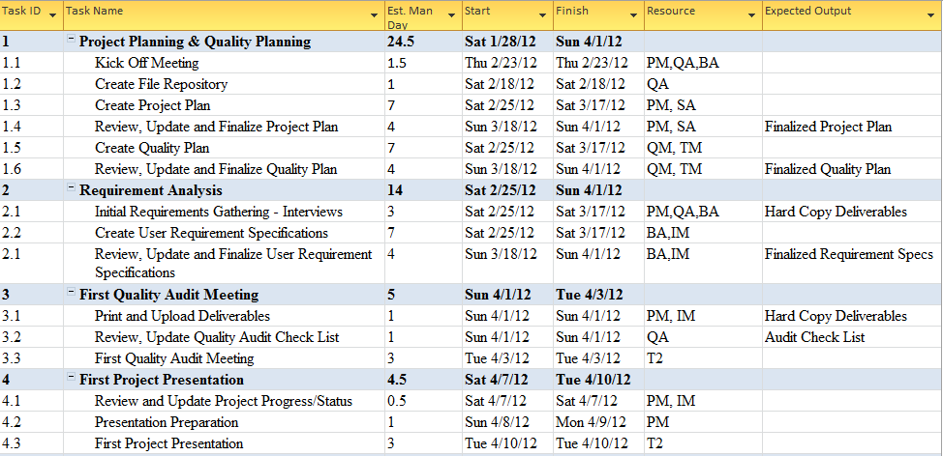
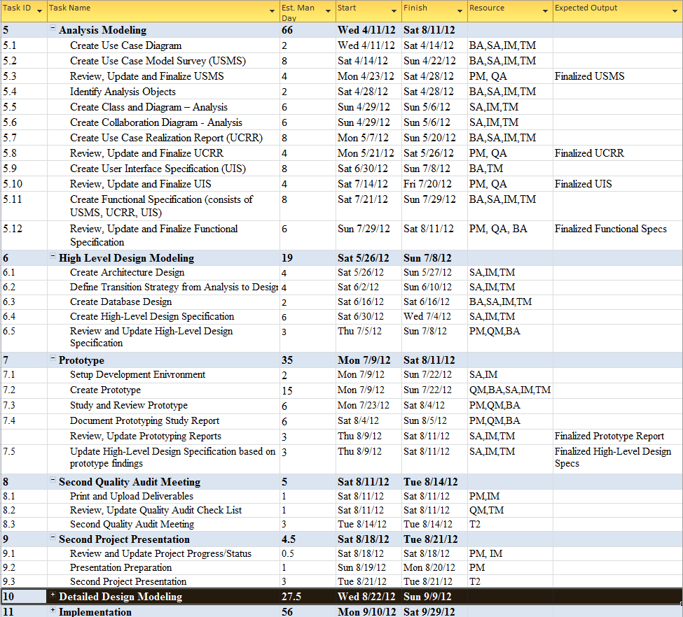
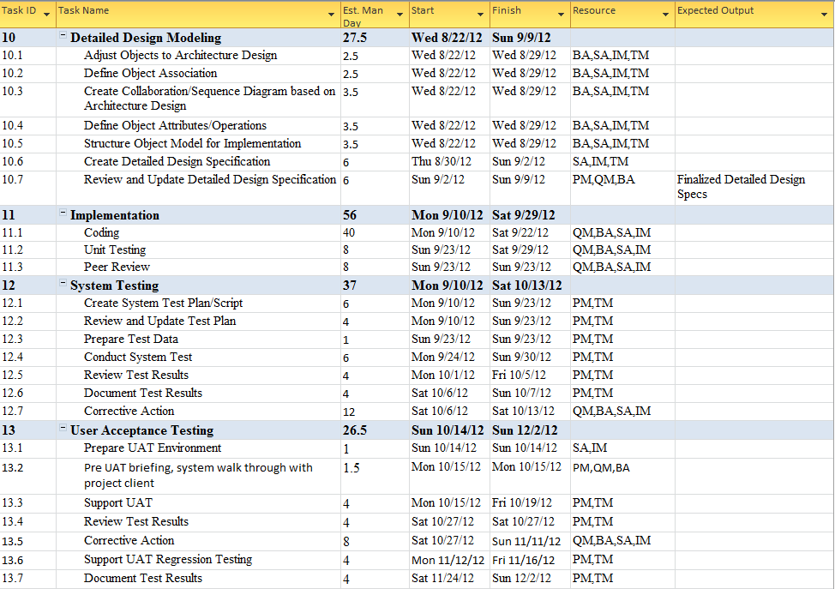
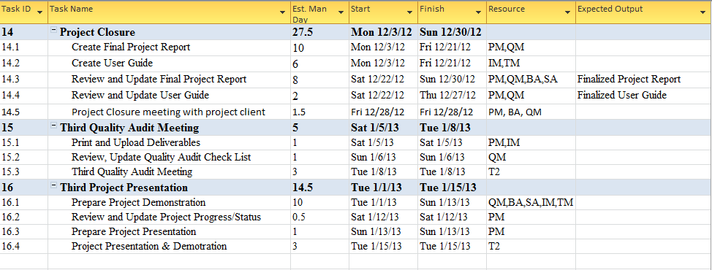

10.8 Risk Questionaires

SN | Risk | Description | Consequences
1 | Team member departure and unavailability | There is a possibility that some team member may leave the team before the project is completed or may not be available when as initially expected. | - Other team members will have to take on the tasks left over by the leaving member. Those who took over the tasks may not have the complete knowledge required to continue the task.  - The remaining team members maybe overloaded as each member will have to take on the tasks left over by the leaving member  - if a team member needs to temporary take off from the project for longer than 2 weeks (oversea work commitment), other Team member will have to temporary stand in and continue on the task else the team may not meet the timeline for some deliverables.
2 | Project client commitment to the project and availability | This project will last for close to a year. The project client may lose interest and commitment to the project. There is also a possibility that the project client have to be on long leave e.g. maternity and unable to provide the required support to the project | - The team will lose support from the project client.  - In worst case, the project may not continue if the project client refuses or unable to provide support required from the project.
3 | Insufficient hardware resource | Only 1 ISS Server is provisioned for this project. There is a possibility that the server may breakdown | - The project may not move if no proper server environment is available
4 | System portability risk | The system may not run well in all browsers. This is due to different browser may interpret javascript, css and html differently | - System usability issue.
5 | Dependency on third-party library and lack of experience in third-party library | The third-party library may have limitation the team is not aware of. | - The system may be buggy  - The solution architect may have to redesign the system  - The team member may required more effort to develop the system than initially expected. This may have an impact on the project schedule
6 | Lack of experience in UI design for Mobile Website | None of the member have experience in designing UI for mobile Website | - Users may refuse to use the system because of its poor UI design
7 | Uncertainty/insufficient requirements | During the kick off meeting, user is uncertain of what they want in the system. The project team has to be pro-actively providing suggestions to the user. | - The system may not value add to the client business  - The system may lack the “intelligent” and “complexity” factor required by MTECH project

10.9 Risks Techniques

SN | Risk | Control Type | Techniques
1 | Team member departure and unavailability |  | - Every project member will undertake a primary and secondary role. E.g. Team Member Alvin will have a primary role as a Quality Manager and Secondary role as a Project Manager. Alvin will have to take on the PM responsibility should the current PM leaves the team or took long offs from the project  - The man day estimated for each member should not exceed 70 days. This will help to ensure that the members will not be severely overloaded should there be a case where they need to take on leaving member’s teak.  - Anticipate all oversea leaves, marriage plan, baby plan, relocation plan etc and factor these to schedule and effort planning
2 | Project client commitment to the project and availability |  | - Continuously keep the project client updated with the project progress and future plans. Understand that the requirements will change over a long period and be open minded and flexible to these changes while ensuring that the change will not significantly affect the project schedule and effort  - Request for a covering officer from project client. Keep the covering officer updated with the project progress and plans.
3 | Insufficient hardware |  | - The server environment will be replicated and back up on a virtual machine. If the main server fail to work. The virtual machine will be activated immediately to avoid any delay due to the unavailability of server environment.
5 | System portability risk |  | - Inform project client that this is a limitation faced by all web application.  - Select 2 most widely used desktop browser and mobile browser. Design and test the system on the selected browsers
6 | Lack of experience in UI design for Mobile Website |  | - Factored in the effort required by the business analyst to study mobile website UI design.  - Business analyst to create a UI specification. Build a prototype to test the UI usability
7 | Uncertainty and insufficient requirements |  | - Perpetually brainstorm for more creative ideas  - Seek advice from ISS mentors  - Create and study prototype to discover potential improvements that can be made to the system

End of Project Plan

